CIS 4911 – SENIOR PROJECT

Picture Marketing’s Social Wall

**User’s Manual**

Members: Steve Noel

Mentor: Carlos Ocampo

04/08/2015

Instructor: Masoud Sadjadi

Mobile Application User Manual - Cast to Chromecast Guide

1. Chrome cast device must be connected to same network as device running the mobile application.
2. Mobile application must be installed on the mobile device.

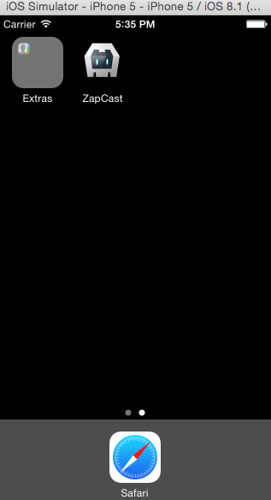

4). User logs into the system using his fotozap credentials.

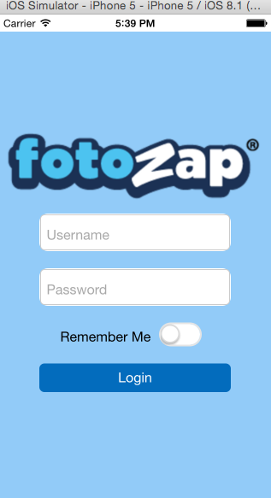

User selects the Chromecast button on the upper left

User selects the device he wants to connect to and the system shall begin streaming the media on the screen.

